Experiment no.:10 Keerthika.K-241901046
Extract Exchangeable image file format (EXIF) Data from Image Files using ExifReader Software
Aim
To extract Exchangeable Image File Format (EXIF) data from image files using ExifReader software.
Procedure
- Download the ExifReader software and locate the executable file named ExifRead.exe.
- Run ExifRead.exe to open the ExifReader application.
- Click the Open button in the application window.
- Browse the system or storage media and select an image file for examination.
- Select a JPEG or JPG image, as these formats commonly contain EXIF metadata.
- Open the selected image file. The image thumbnail will appear on the left side of the window.
- Examine the EXIF data displayed on the right side of the application.
- Identify the available metadata, such as camera name, date and time, camera settings, shutter speed, exposure, flash usage, and compression details.
- Check whether GPS coordinates or other location-related information are available in the image metadata.
- Record the extracted information for forensic investigation.
Observation
ExifReader is a Windows-based tool used to extract EXIF metadata from image files. The extracted information may include camera details, date and time, exposure settings, shutter speed, flash usage, and GPS coordinates when available. This metadata can help forensic investigators examine the technical details and possible origin of an image.
Observation Table
S. No. | Particulars | Observation
1 | Tool Used | ExifReader
2 | Executable File | ExifRead.exe
3 | Input File | Image.jpeg
4 | Image Format | JPEG/JPG
5 | Camera Information | Huffman
6 | Date and Time | Thu oct 01 2026 / 14:09:50
7 | Camera Settings | Display device
8 | GPS Information | Available / Not available
9 | Extracted Metadata | Record the actual metadata displayed
10 | Status | Record the actual result

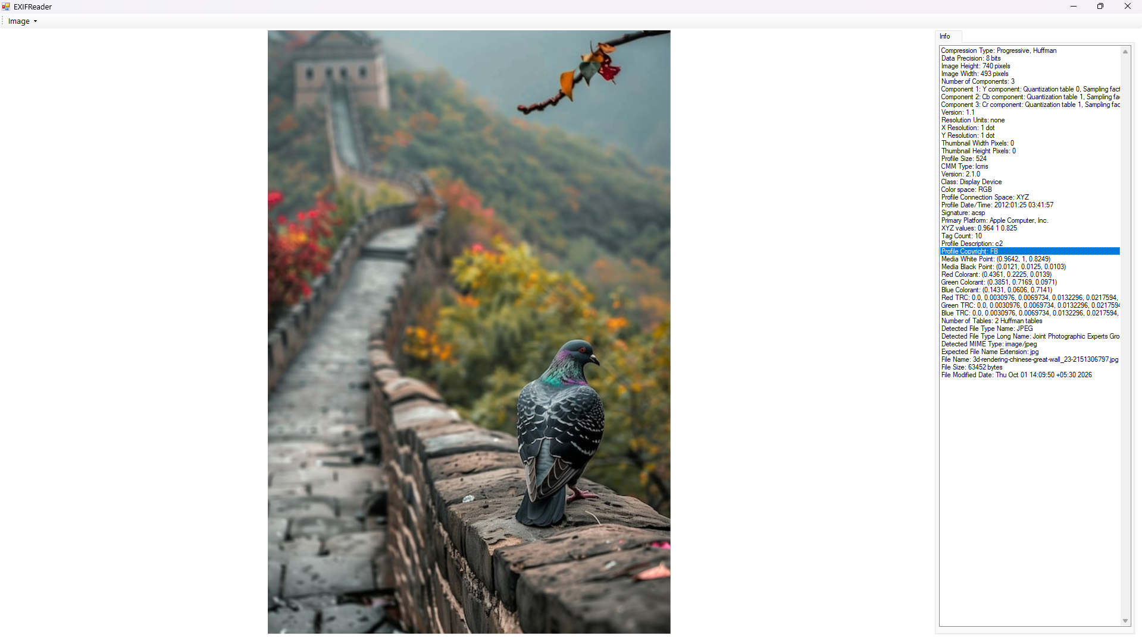

Result
Thus, EXIF data was examined using ExifReader software, and the available image metadata was analyzed for digital forensic investigation.

